Exercise 7 - Financial Forecasting

Step 1: Understand Recursive Algorithms –
Recursion is a technique where a function solves a problem by calling itself on a smaller version of the same problem, until it reaches a base case simple enough to answer directly. Each recursive call breaks the task down further, and the results are combined on the way back up to produce the final answer.

Step 2: Setup –

First, a helper function looks back over the historical revenue and works out the growth rate between each pair of consecutive quarters, then averages them into a single representative growth rate. This average rate is what the recursive method will apply at every step,

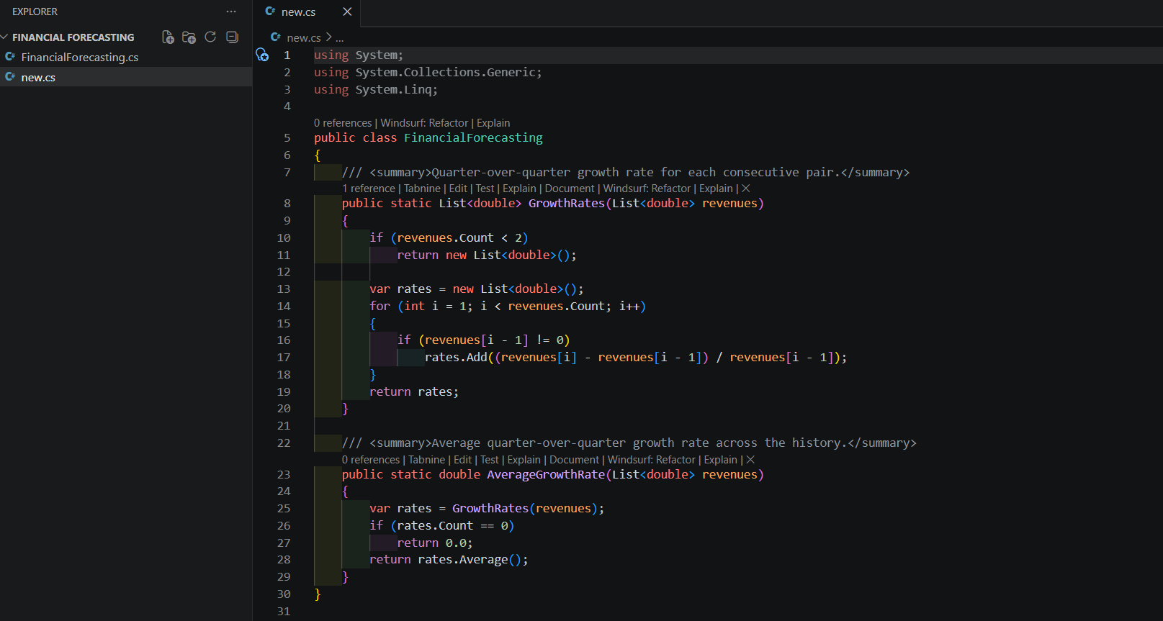

with the growth rate established, the core method is a recursive function that calculates the future value: to project n quarters ahead, it first projects n-1 quarters ahead (the smaller subproblem), then grows that result by one more period. The base case is n = 0, which simply returns the current known value.
Step 3: Implementation –

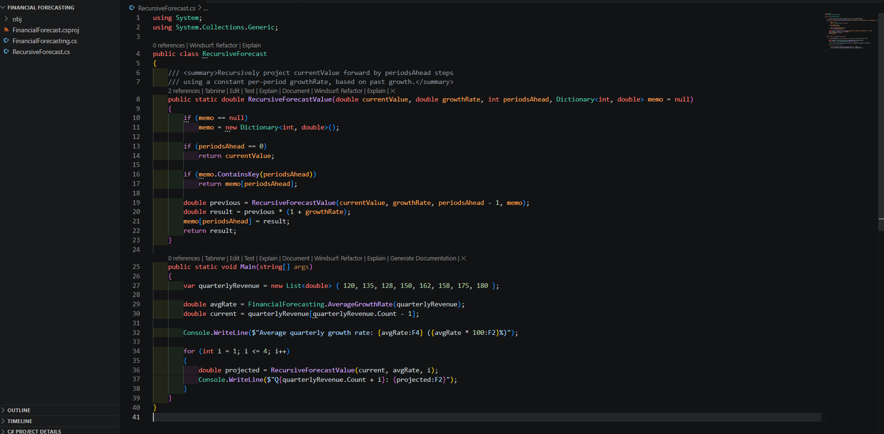

CODE Output:
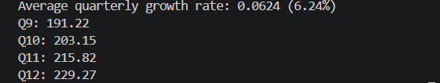

Each value builds directly on the one before it: Q10 is Q9 grown by the average rate, Q11 is Q10 grown by the same rate, and so on.
Step 4: Analysis –
- Time complexity: without memoization, each call to recursive_forecast(n) makes one call to recursive_forecast(n-1), so the recursion depth is n and each level does constant work — this gives O(n) time and O(n) space for the call stack, for a single forecast of n periods ahead.
- Optimizing with memoization: the memo dictionary threaded through the calls above stores each period's result the first time it is computed, so a later request for a larger or smaller horizon reuses the already-solved subproblems instead of recalculating them. This is the classic recursion optimization for overlapping subproblems (the same idea behind memoized Fibonacci or dynamic programming): it turns the repeated-work case from O(n·k) back down to O(n) total across all forecasts, at the cost of O(n) extra memory to store the cache.

